Session 2: Christ in the offeings (Leviticus 1-7)
1. The Incomprehensible Christ Revealed in the Offerings
When we begin studying the offerings, we must remember that Christ Himself is infinite. His Person cannot be measured, mapped, or mastered. Paul says that even one glory of Christ — His love — has breadth, length, depth, and height (Eph. 3:18). If one attribute of Jesus is beyond human comprehension, how much more the fullness of Christ Himself!
The five offerings are not five separate doctrines, but five windows into the same glorious Person — each revealing one facet of His inexhaustible beauty. All of Scripture shines with glimpses of this vast Christ. Every offering, every servant, every moment in God’s dealings with His people reveals a facet of His glory:
Moses — His forbearance and faithfulness, David — His heart after God’s own heart, Joseph — His suffering and exaltation, Aaron — His priestly intercession, The five offerings — the fullness of His redeeming love
Each offering unveils one dimension of His infinite Person — the breadth of His fellowship, the length of His obedience, the depth of His suffering, and the height of His devotion to the Father. No single type can contain Him; yet together they trace the contours of His perfect, completed Cross. Every offering is a facet of Jesus’ one perfect sacrifice. “Behold! The Lamb of God who takes away the sin of the world!” (John 1:29)
God’s Order and Man’s Order
To God, everything begins with His Son. He first beholds the perfect obedience of Christ, the Finished Work offered up to Him as a sweet aroma.Therefore, in God’s order, the path begins with Christ’s perfection and ends in fellowship, because He sees us in His Son, already accepted.
To man, the journey begins elsewhere. We start with our sin, guilt, and distance. Only then do we move toward the altar, toward cleansing and acceptance. So in man’s order, the path begins with sin and ends in peace, because we travel from guilt to grace.
Thus Scripture presents both orders side by side:
- God begins with the Burnt Offering — Christ’s perfect devotion.
- Man begins with the Sin Offering — our deep need.
One is God’s view from above; the other is man’s experience from below. Both meet in Christ, where God’s satisfaction and man’s peace become one.
Though God commanded Israel to circumcise the flesh, His real desire was the circumcision of the heart. The outward act was only a shadow of an inward reality. Likewise, the sacrifices, rituals, washings, and priesthood were never ends in themselves — they pointed to deeper spiritual truths. Every external command anticipated its inner fulfilment in Christ: the true circumcision, the perfect sacrifice, the final cleansing, and the eternal Priesthood. What the law required outwardly, God intended inwardly — and Christ completes it fully.2.2 Introduction to the Five Sacrifices

2 Introduction to the Five Sacrifices
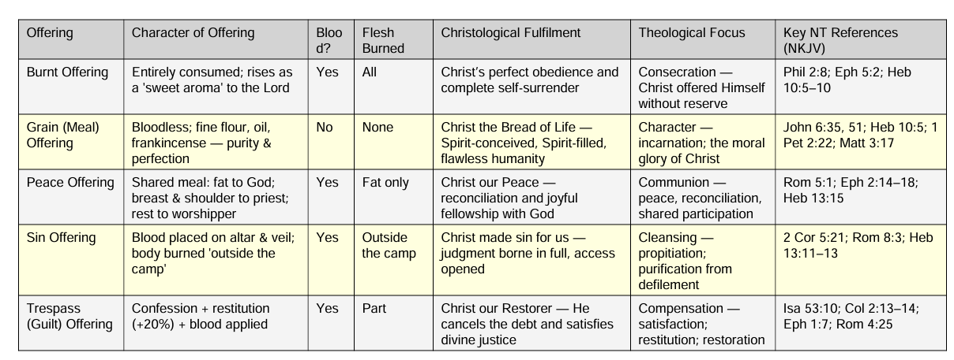
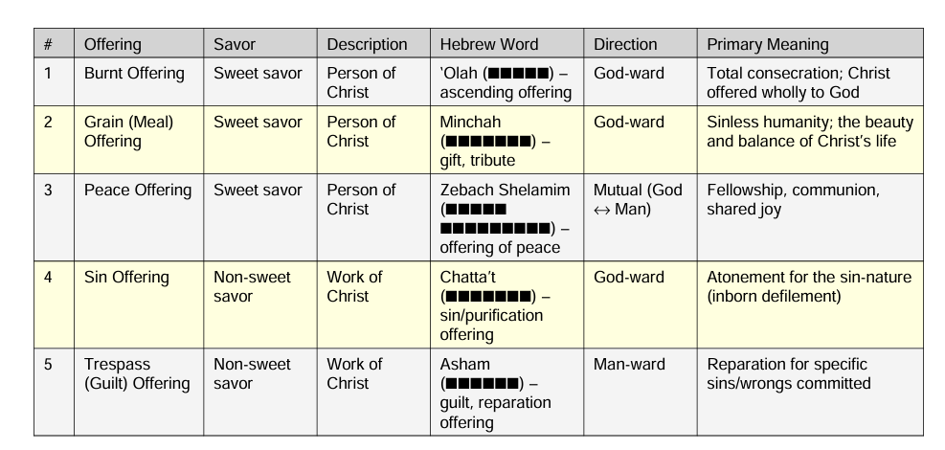
The five offerings together give a complete picture of Christ—His Person and His Work.
Each offering reveals one facet of His glory, brought together in the table below.

3. Important Deeper Truths
No | Key Truth | Meaning in Leviticus | Fulfilled in Christ
1 | God provides the sacrifice | God chose the offering | Christ is God’s Lamb
2 | God’s holiness never changes | Only holy offerings accepted | Christ alone perfect
3 | True sacrifice must be willing | Animals came unwillingly | Christ gave Himself freely
4 | Fire shows judgment | Fire never went out | Christ bore full judgment
5 | Fat belongs only to God | Richest part for God | Christ’s heart delighted God
6 | Blood meets God first | Applied first to altar | Cross satisfied God first
7 | No leaven | No corruption allowed | Christ is sinless
8 | Salt = covenant | Salt in every offering | Christ's covenant eternal
9 | Ashes = finished work | Nothing left to burn | “It is finished.”
10 | Goal is fellowship | Shared meal offering | Christ brings communion

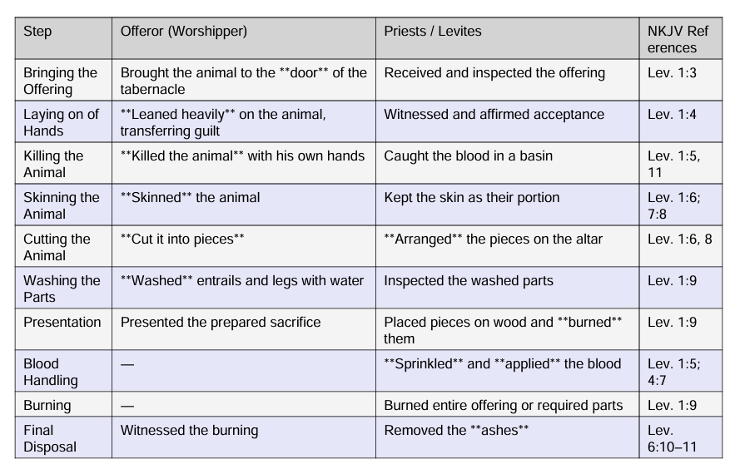
4. What the worshipper and the priest did

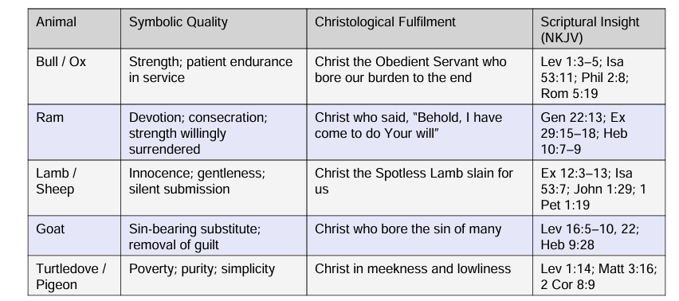
5. Sacrificial Animals

All point to the One who fulfills them all: “Worthy is the Lamb who was slain.” (Rev. 5:12)

6. Sins of Ignorance & Presumption
Sins of Ignorance vs. Presumptuous Sins — Type & Antitype
Aspect | Type in the Old Testament | Antitype Fulfilled in Christ | Key References
1. Nature of Sin | Sins of Ignorance (shegāgāh) — failures, mistakes, weaknesses, blindness | Christ cleanses the conscience, removing both the act and the stain | Lev 4; Num 15:27–28; Heb 9:14
 | Presumptuous Sins (“with a high hand”) — deliberate, defiant rebellion | Christ shows mercy to repentant rebels; His blood reaches beyond the Law’s limits | Num 15:30–31; Acts 9; Heb 7:25; Ps 32:5
2. Provision under the Law | Sin offering provided; forgiveness pronounced | Christ’s blood provides complete forgiveness and inward cleansing | Lev 4:20, 26, 31; Heb 9:14
 | No sacrifice provided; offender “cut off” | Christ receives even high-handed sinners who repent (e.g., David, Paul) | Num 15:30–31; Ps 51:1–4; 1 Tim 1:13–16
3. Purpose of the Law | Teach dependence on atonement; awaken the conscience | Christ is the final sacrifice, fulfilling what the Law pointed to | Heb 10:1–4, 14
 | Expose the pride and rebellion of the heart; limit of the Law’s power | Christ brings grace beyond the Law — “grace and truth came through Jesus Christ” | John 1:17; Rom 5:20
4. OT Outcome | Forgiveness and restored access | Full cleansing: “purge your conscience” | Lev 4; Heb 9:14
 | No remedy; judgment and exclusion | Grace extended: “He is able to save to the uttermost” | Heb 7:25
5. Fulfillment in Christ’s Blood | Christ’s blood cleanses sins committed in ignorance | “The blood of Jesus Christ… cleanses us from all sin” — all includes both categories | Heb 9:14; 1 John 1:7
 | Christ’s sacrifice reaches beyond the Law to presumptuous sinners who repent | Mercy to David (Ps 51), mercy to Paul (1 Tim 1:13–16), mercy to rebels (Luke 23:34) | Ps 51:1–7; 1 Tim 1:13–16; Luke 23:34
The Law forgave only sins of ignorance, but the blood of Christ cleanses both—our weaknesses and our rebellions—bringing grace where the Law could only condemn.
7. Why these animals and Why so many details
A. Why These Animals?
(Christ-centered reasons God chose these five animals)

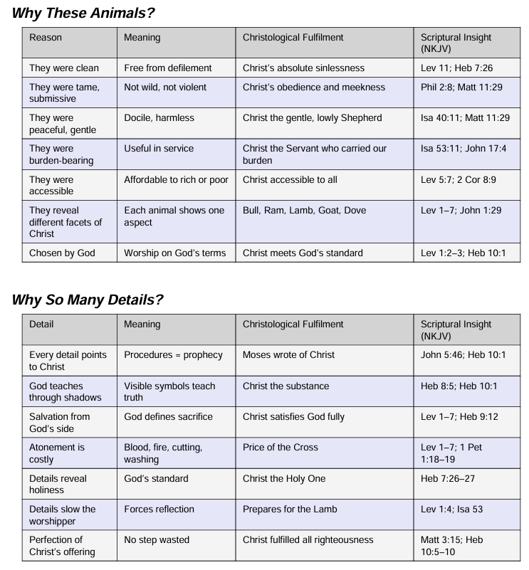

7. Outside the Camp
“Outside the Camp” and the Two Hebrew Words for “Burn”. Leviticus uses two different Hebrew verbs for “burn,” and each carries a distinct spiritual meaning. One speaks of God’s delight, the other of God’s judgment — and both meet in Christ at the Cross.
Verb | Meaning | Location | Symbolism | Fulfilled in Christ
qāṭar (קָטַר) | To rise as incense | On the altar | Acceptance and fragrance | “A sweet-smelling aroma” (Eph. 5:2)
śāraph (שָׂרַף) | To burn in judgment | Outside the camp | Rejection and curse-bearing | “Suffered outside the gate” (Heb. 13:12)
Why it matters:
- qāṭar = God’s delight in Christ’s obedience
- śāraph = God’s judgment on sin placed on Christ
At Calvary, the fragrance of His obedience and the fire of judgment met in one place. At the Cross, Christ was both the fragrant offering on the altar and the judged sacrifice outside the camp.

8. Sins of Ignorance & Presumption
Sins of Ignorance vs. Presumptuous Sins — Type & Antitype
Aspect | Type in the Old Testament | Antitype Fulfilled in Christ | Key References
1. Nature of Sin | Sins of Ignorance (shegāgāh) — failures, mistakes, weaknesses, blindness | Christ cleanses the conscience, removing both the act and the stain | Lev 4; Num 15:27–28; Heb 9:14
 | Presumptuous Sins (“with a high hand”) — deliberate, defiant rebellion | Christ shows mercy to repentant rebels; His blood reaches beyond the Law’s limits | Num 15:30–31; Acts 9; Heb 7:25; Ps 32:5
2. Provision under the Law | Sin offering provided; forgiveness pronounced | Christ’s blood provides complete forgiveness and inward cleansing | Lev 4:20, 26, 31; Heb 9:14
 | No sacrifice provided; offender “cut off” | Christ receives even high-handed sinners who repent (e.g., David, Paul) | Num 15:30–31; Ps 51:1–4; 1 Tim 1:13–16
3. Purpose of the Law | Teach dependence on atonement; awaken the conscience | Christ is the final sacrifice, fulfilling what the Law pointed to | Heb 10:1–4, 14
 | Expose the pride and rebellion of the heart; limit of the Law’s power | Christ brings grace beyond the Law — “grace and truth came through Jesus Christ” | John 1:17; Rom 5:20
4. OT Outcome | Forgiveness and restored access | Full cleansing: “purge your conscience” | Lev 4; Heb 9:14
 | No remedy; judgment and exclusion | Grace extended: “He is able to save to the uttermost” | Heb 7:25
5. Fulfillment in Christ’s Blood | Christ’s blood cleanses sins committed in ignorance | “The blood of Jesus Christ… cleanses us from all sin” — all includes both categories | Heb 9:14; 1 John 1:7
 | Christ’s sacrifice reaches beyond the Law to presumptuous sinners who repent | Mercy to David (Ps 51), mercy to Paul (1 Tim 1:13–16), mercy to rebels (Luke 23:34) | Ps 51:1–7; 1 Tim 1:13–16; Luke 23:34

The Law forgave only sins of ignorance, but the blood of Christ cleanses both—our weaknesses and our rebellions—bringing grace where the Law could only condemn.

2.9 The Grain Offering
# | Symbol | Meaning | Fulfilled in Christ | References
1 | Bloodless Offering | Deals not with sin but with perfection of life | Christ’s flawless humanity | Heb 7:26; 1 Pet 2:22
2 | Fine Flour | Perfect balance; no unevenness | Perfectly balanced character—grace & truth | John 1:14; Ps 45:2
3 | Oil Mixed In | Spirit within from conception | Conceived by the Holy Spirit | Matt 1:20; Luke 1:35
4 | Oil Poured On | Anointing for service | Anointed at baptism for ministry | Matt 3:16–17; Acts 10:38
5 | Frankincense | Fragrance entirely for God | Father’s delight in Christ’s inner life | Lev 2:2; Eph 5:2
6 | No Leaven | No corruption; no sin | Christ without sin or decay | 1 Cor 5:7–8; John 14:30
7 | No Honey | No human sentimentality | Divine love, not natural sweetness | Lev 2:11
8 | Salt | Purity; covenant permanence | Words seasoned with pure grace and truth | Lev 2:13; Col 4:6
9 | Part for God, Part for Priests | God delights; believers feed on Christ | We partake of His perfections | Lev 2:3; John 6:57
10 | Beside the Burnt Offering | Life and sacrifice together | Perfect life qualifies the perfect sacrifice | Lev 2:1; Heb 10:5–10
The Grain Offering reveals the inward beauty of Christ—Spirit-conceived, Spirit-filled, sinless, fragrant to God, and nourishment to His people.
Home Preparation of the Grain Offering
Preparation Method | Meaning in the Offering | Fulfilled in Christ | References
1. Oven-baked cakes | Hidden, interior suffering; heat applied out of public view | Christ’s inward, unseen sufferings known only to the Father | Lev 2:4; Ps 22:14; Luke 22:44
2. Pan-fried cakes (flat pan / griddle) | Surface exposed; quick intense heat | Christ’s open sufferings before men—public trials, rejection | Lev 2:5; Isa 53:3; John 18–19
3. Covered pan / deep vessel | Slow, enclosed heat; pressure from all sides | Christ pressed in Gethsemane; “My soul is exceedingly sorrowful” | Lev 2:7; Matt 26:38; Heb 5:7
4. Prepared at home | Offering required thought, effort, and personal involvement | Christ was formed in the “womb of Mary”—true humanity, real domestic life | Lev 2:1; Luke 2:40–52
5. Brought voluntarily to the tabernacle | Worship originates from the heart, not ritual | Christ’s perfect life was offered willingly: “Behold, I come” | Lev 2:1; Heb 10:7–9
6. Variety of forms | Many shapes, but one offering | Many expressions of Christ’s beauty—yet one perfect life | Lev 2:4–7; John 1:14

The different ways the Grain Offering was prepared—oven, pan, griddle—reveal the various dimensions of Christ’s sufferings and the hidden beauty of His sinless life at home and in public.
The Grain Offering reveals the inward beauty of Christ—Spirit-conceived, Spirit-filled, sinless, fragrant to God, and nourishment to His people.
It was prepared at home in many ways—baked in the oven, cooked on a pan, or pressed on a griddle (Lev. 2:4–7). These different methods show the varied pressures and hidden sufferings Christ endured: the unseen inward agony known only to the Father, the public trials and rejections before men, and the deep inward sorrow of Gethsemane. Every form of preparation was thoughtful and personal, reminding us that Christ’s perfect humanity was shaped in the ordinary, hidden places of daily life before it was offered to God.
Three-fold Glories of the Lord Jesus Christ
The Inward Beauty and Moral Glory of Christ:
The Grain Offering reveals the inward, hidden beauty of Christ—Spirit-conceived, Spirit-filled, sinless, fragrant to God, and nourishment to His people. It was prepared at home before being offered: baked in the oven (hidden heat), cooked on the pan (open, visible heat), or pressed on the griddle (steady, penetrating heat) (Lev. 2:4–7). These preparations symbolize the varied pressures Christ endured—His unseen inward sorrows known only to the Father, His public trials before men, and His deep inward agony in Gethsemane. In every circumstance, the “fine flour” of His character remained perfectly even, perfectly pure, and perfectly fragrant.
His personal glory as the eternal Son was veiled, seen only by faith (Matt. 16:16) or by divine unveiling on the mount (Matt. 17:1–9). His official glory as the Lord of angels was restrained—He walked in lowliness, though He could have summoned “twelve legions of angels” (Matt. 26:53). But His moral glory could never be hidden. He knew when to submit to His mother (Luke 2:51), when to set aside her claims (Luke 8:21; John 2:3–4), and when to honor her unsought at the Cross (John 19:27). This flawless balance is exactly what the fine flour portrays.
His relation to the world was equally perfect. To its temptations, He was a Conqueror, refusing all its attractions. To its pollutions and enmity, He was a Sufferer, grieved by its evil and opposed by its spirit. To its misery, He was a Benefactor, healing, blessing, teaching, feeding, and returning good for evil. Whether hidden in the house, tested in the open, or pressed in deep sorrow, Christ remained the same—the Bread of God, fragrant to the Father and life for His people (John 6:35, 57).

2.11 Manna & the Grain Offering
